**Lab assignment <2>**

**Fa24-elc-176**

Q1)

#include <iostream>

using namespace std;

int main()

{

int sum =0;

int num =2;

while(num<=30)

{

sum += num;

num += 2;

}

cout<<"the sum of even integers from 1 to 30 is:"<<sum<<endl;

return 0;

}



Q2)

#include <iostream>

using namespace std;

int main()

{

int product =1;

int num =1;

while(num<=19)

{

product *= num;

num += 2;

}

cout<<"the product of odd integers from 0 to 19 is:"<<product<<endl;

return 0;

}



Q3)

#include <iostream>

using namespace std;

int main()

{

int num;

int factorial =1;

cout<<"enter a number :";

cin>>num;

int i=1;

while(i<=num)

{

factorial*=i;

i++;

}

cout<<"the factorial of number:"<<num<<"is"<<factorial<<endl;

return 0;

}



Q4)

#include <iostream>

using namespace std;

int main()

{

int num1,num2,num3,num4,num5;

cout<<"enter five numbers:";

cin>>num1>>num2>>num3>>num4>>num5;

if(num1%2==0)

{

cout<<"even"<<endl;

}

else

{

cout<<"odd"<<endl;

}

if(num2%2==0)

{

cout<<"even"<<endl;

}

else

{

cout<<"odd"<<endl;

}

if(num3%2==0)

{

cout<<"even"<<endl;

}

else

{

cout<<"odd"<<endl;

}

if(num4%2==0)

{

cout<<"even"<<endl;

}

else

{

cout<<"odd"<<endl;

}

if(num5%2==0)

{

cout<<"even"<<endl;

}

else

{

cout<<"odd"<<endl;

}

return 0;

}

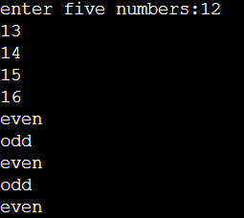

Q5) #include <iostream>

using namespace std;

int main()

{

int largest, smallest,num;

cout<<"enter an integer:";

cin>>num;

largest=num;

smallest=num;

for(int i=1;i<5;i++)

{

cout<<"enter another integer:";

cin>>num;

if(num>largest)

{

largest=num;

}

if(num<smallest)

{

smallest=num;

}

}

cout<<"largest integer:"<<largest<<endl;

cout<<"smallest integer:"<<smallest<<endl;

return 0;

}

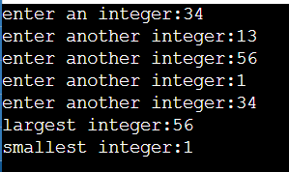

Q6) #include <iostream>

using namespace std;

int main()

{

int sum=0;

for(int i=0;i<=10;i++){

sum+=i;

}

cout<<"the sum of all values between 0 and 10 is :"<<sum<<endl;

return 0;

}

